**L. VARSHINI**

**192372045**

**CSA1618 DWDM**

**EXPERIMENT-26**

**FREQUENT PATTERN MINING USING FP GROWTH THROUGH WEKA TOOL**

**AIM:**

To create frequent pattern mining using FP Growth through weka tool.

**PROCEDURE:**

1. Download and install WEKA.
2. Open WEKA and Choose "Explorer" from the main menu.
3. Under Preprocess, Click on the open file button and select the datasetEnsure that your dataset contains categorical (nominal) attributes (FP-Growth does not work well with numerical data).
4. Go to the "Associate" tab for association rule mining. In the "Associate" tab, click "Choose" and select FPGrowth (found under weka.associations).
5. Click on "FPGrowth" to configure its parameters: minSupport: Set minimum support value (e.g., 0.1 for 10%), maxNumberOfItems: Maximum size of itemsets (default = unlimited), rules: Set to true to generate association rules, metricType: Choose confidence, lift, or leverage for rule evaluation.
6. Click "OK" and then "Start" to begin clustering. Save the file.

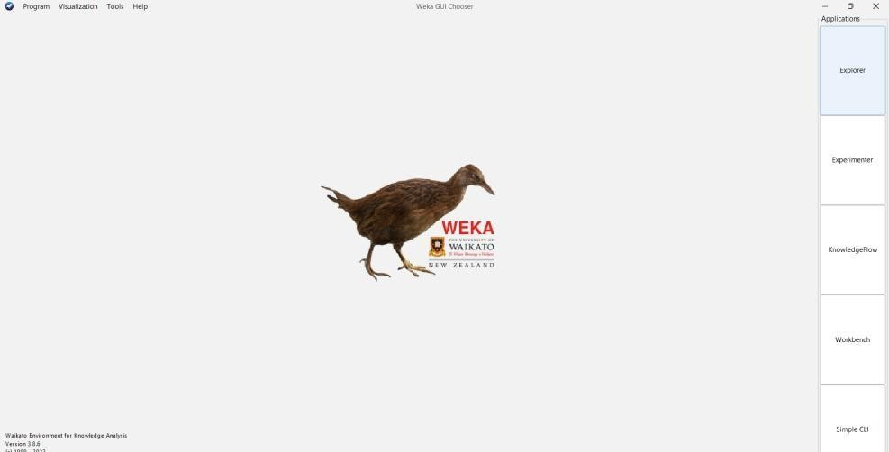

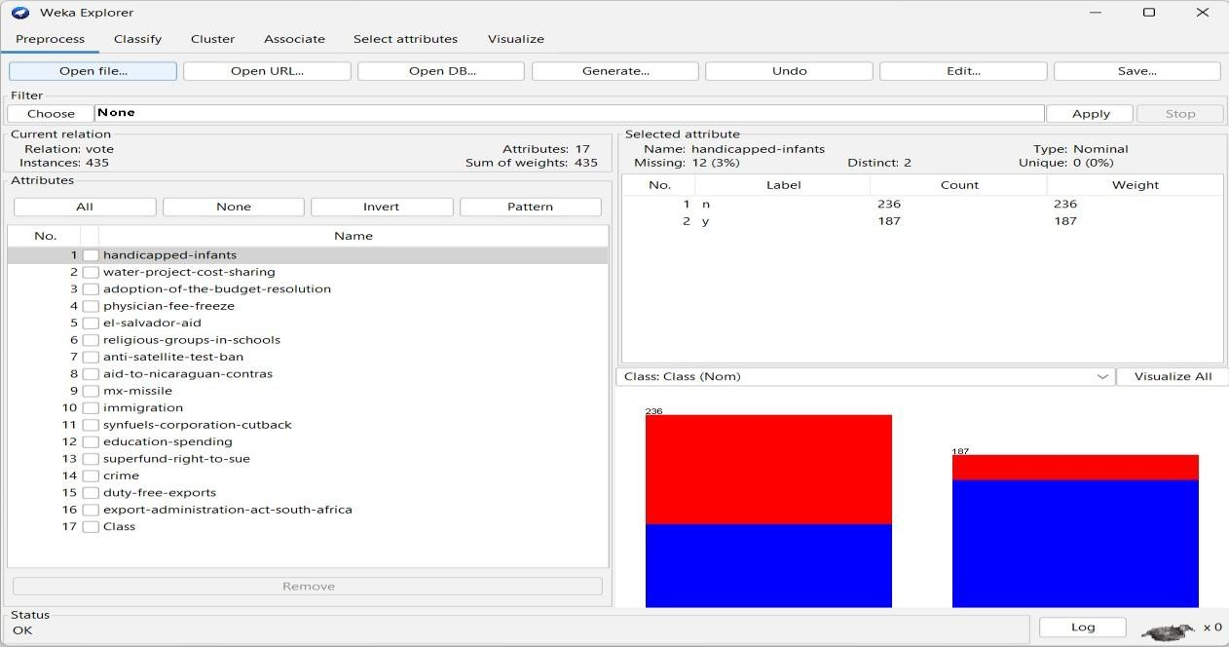

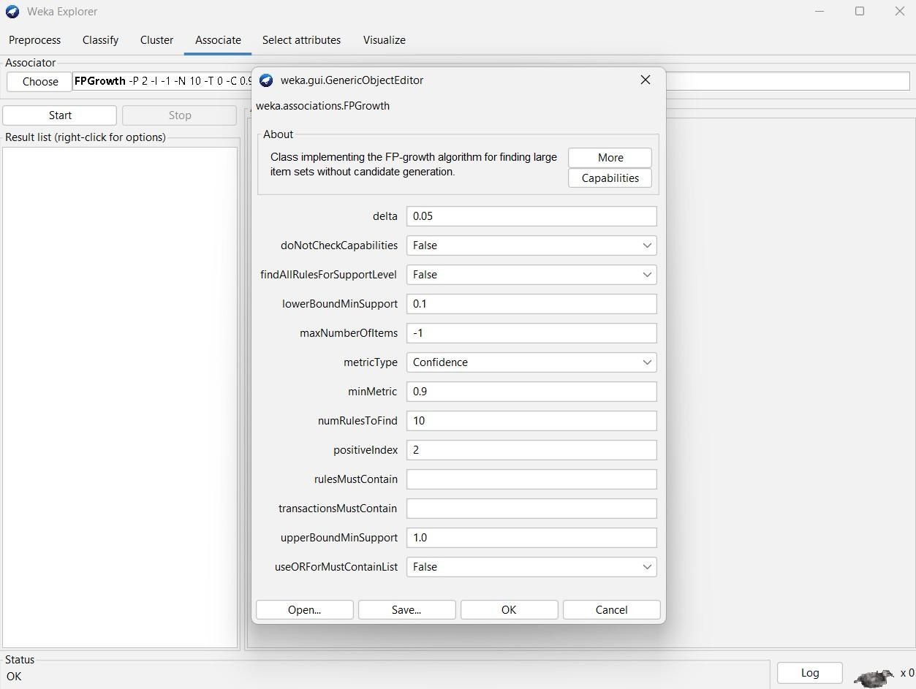

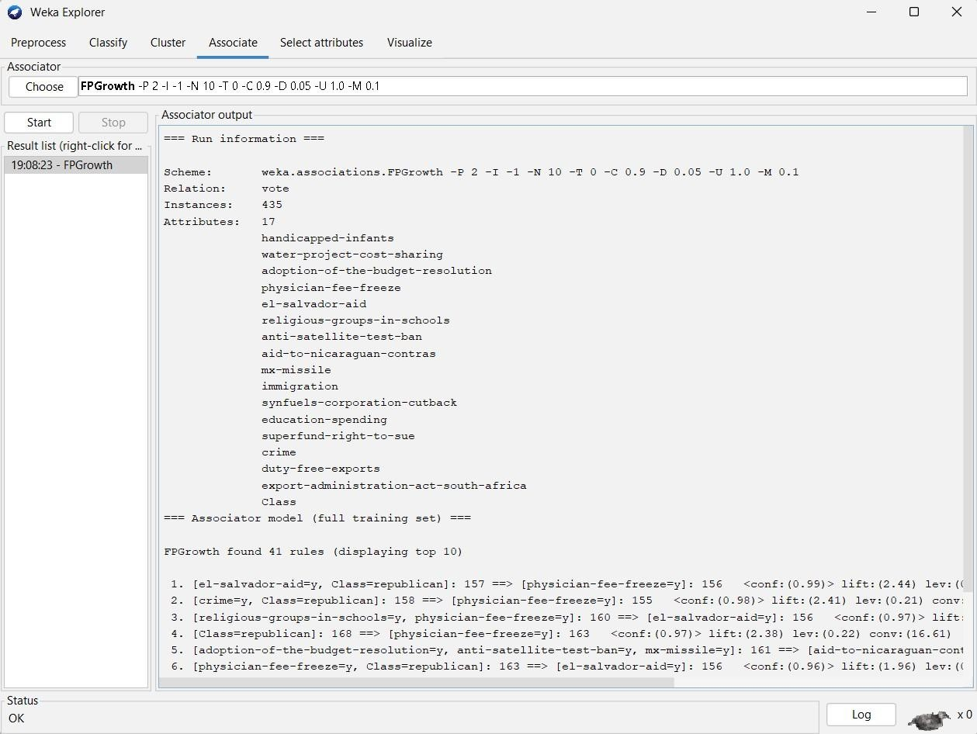

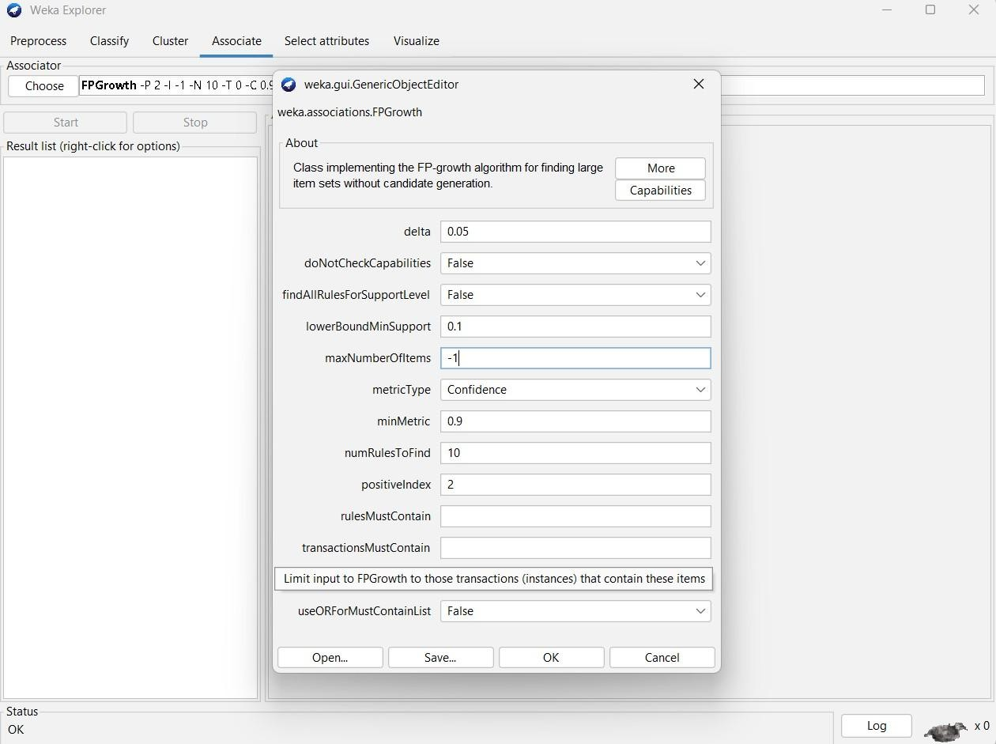

**OBSERVATION:**

=== Run information ===

Scheme: weka.associations.FPGrowth -P 2 -I -1 -N 10 -T 0 -C 0.9 -D 0.05 -U 1.0 -M 0.1

Relation: vote

Instances: 435 **Attributes: 17**

handicapped-infants water-project-costsharing adoption-of-the-budgetresolution physician-fee-freeze el-salvador-aid religious-groups-in-

schools anti-satellite-test-ban aidto-nicaraguan-contras mx-missile immigration synfuels-corporationcutback education-spending superfund-right-to-sue crime duty-free-exports export-administrationact-south-africa

Class

=== Associator model (full training set) ===

FPGrowth found 41 rules (displaying top 10)

1. [el-salvador-aid=y, Class=republican]: 157 ==> [physician-fee-freeze=y]: 156 <conf:(0.99)> lift:(2.44) lev:(0.21) conv:(46.56)
2. [crime=y, Class=republican]: 158 ==> [physician-fee-freeze=y]: 155 <conf:(0.98)> lift:(2.41) lev:(0.21) conv:(23.43)
3. [religious-groups-in-schools=y, physician-fee-freeze=y]: 160 ==> [el-salvador-aid=y]: 156

<conf:(0.97)> lift:(2) lev:(0.18) conv:(16.4)

1. [Class=republican]: 168 ==> [physician-fee-freeze=y]: 163 <conf:(0.97)> lift:(2.38) lev:(0.22) conv:(16.61)
2. [adoption-of-the-budget-resolution=y, anti-satellite-test-ban=y, mx-missile=y]: 161 ==> [aidtonicaraguan-contras=y]: 155 <conf:(0.96)> lift:(1.73) lev:(0.15) conv:(10.2)
3. [physician-fee-freeze=y, Class=republican]: 163 ==> [el-salvador-aid=y]: 156 <conf:(0.96)> lift:(1.96) lev:(0.18) conv:(10.45)
4. [religious-groups-in-schools=y, el-salvador-aid=y, superfund-right-to-sue=y]: 160 ==> [crime=y]:

153 <conf:(0.96)> lift:(1.68) lev:(0.14) conv:(8.6)

8. [el-salvador-aid=y, superfund-right-to-sue=y]: 170 ==> [crime=y]: 162 <conf:(0.95)> lift:(1.67) lev:(0.15) conv:(8.12) 9. [crime=y, physician-fee-freeze=y]: 168 ==> [el-salvador-aid=y]: 160

<conf:(0.95)> lift:(1.95) lev:(0.18) conv:(9.57) 10. [el-salvador-aid=y, physician-fee-freeze=y]: 168

==> [crime=y]: 160 <conf:(0.95)> lift:(1.67) lev:(0.15) conv:(8.02)

**RESULT:**

Thus, the analysis of FP growth algorithm using weka tool has been successfully completed. Incase of changing the upper bound and lower bound values there is a change in the number of rules that are found.